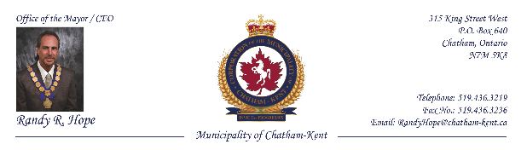

January 16, 2014

Email: david.ullrich@glslcities.org

Great Lakes St. Lawrence Cities Initiative
20 North Wacker Drive
Suite 27011
Chicago, Illinois 60606

Attention: Mr. David Ullrich, Executive Director

Dear Mr. Ullrich:

RE: Kincardine Location of a Deep Geologic Repositiory

The Municipality of Chatham-Kent Council, at its meeting held on January 13, 2014, approved the following resolution:

“Whereas the Municipality of Kincardine had offered to host a Deep Geologic Repository (DGR) of low and intermediate level nuclear waste at the Bruce Nuclear Power Station site, supported by Ontario Power Generation (OPG).

And Whereas concern has been expressed by other Municipalities in both Canada and the United States, as well as individuals, citizens, and environmental groups;

And Whereas the Municipality of Chatham-Kent, in the Province of Ontario, shares many of those concerns, including, but not solely related to, the risk of embedment of nuclear waste at a site less than one kilometer from the Great Lakes, a source of drinking water to 40 million people and supplying 21% of the world’s fresh water;

…/2

Mr. David Ullrich
Great Lakes St. Lawrence Cities Initiative
January 16, 2014
Page 2

And Whereas the proposed site is in limestone above an ancient waterbed, and there has been no intensive research done on other sites available in the granite of the Canadian Shield, or elsewhere;

And Whereas there has not been a disaster/containment plan articulated;

Be It Resolved that the Municipality of Chatham-Kent is not in support of the Kincardine location for a DGR at this time, and requests more information, alternatives and plans be presented, and more research and results be reported and critically reviewed before a final decision is made.”

Please distribute this resolution to the appropriate authorities and interested parties.

Thank you for your attention to this very important matter.

Sincerely,

Randy R. Hope, Mayor/CEO
Municipality of Chatham-Kent

